Season’s Greetings from the Roses
--- 2012 in pictures ---
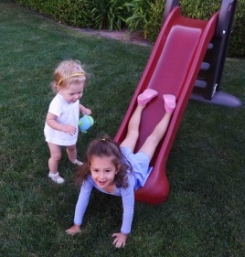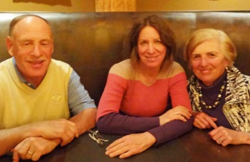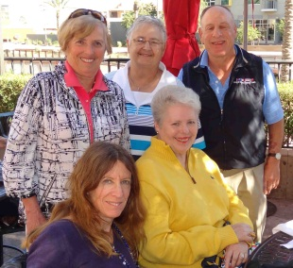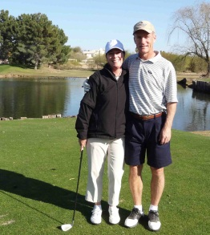
Jan: Granddaughters, Lucia & Caroline; Feb: with Mark’s sister, Jane in Scottsdale, AZ; reunions w Sandoz alumni
by Nov Lucia mastered the slide (Carole Dempsey & Sandee and Bill/Carolyn Shine at Stone Creek, Phoenix)
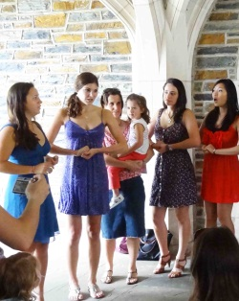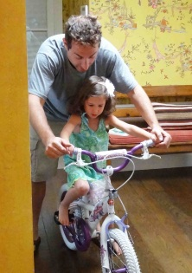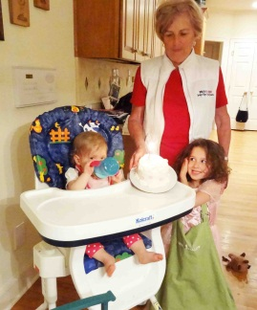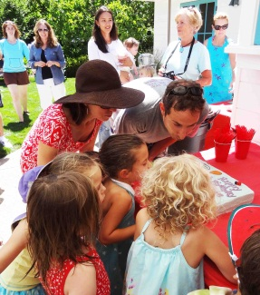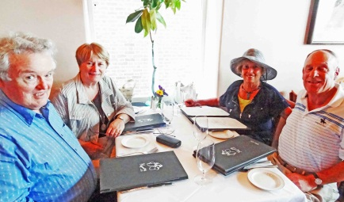
Apr: at Katherine’s 15th at Duke; and Apr: Lucia’s 1st birthday; Caroline’s 4th in July May: Spoleto (Charleston) with close
Todd introduces Caroline to a 2-wheeler friends, Bill and Andrea Bartlett
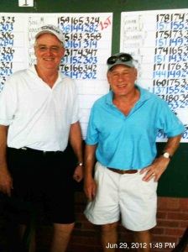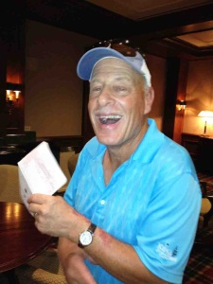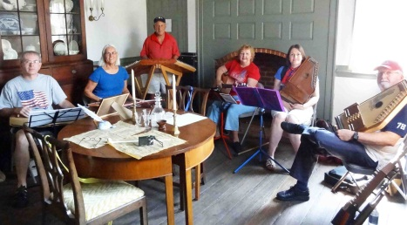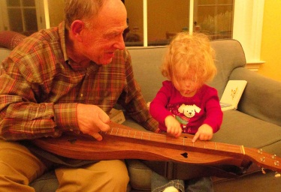
Jun: Golf buddy, Dave Goulding and Mark won Jul: on hammered dulcimer w Triangle Folk Ensemble performing a medley of
the senior “A” flight; Mark’s first hole-in-one patriotic tunes on the 4th; gently introducing Lucia to the mountain dulcimer
+ a “fleeting” single digit handicap in July
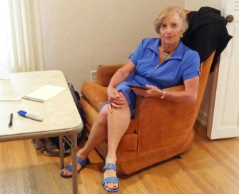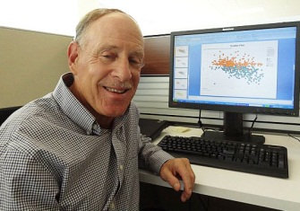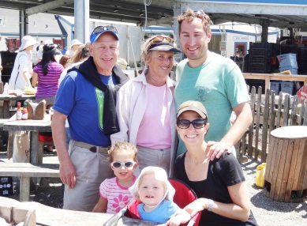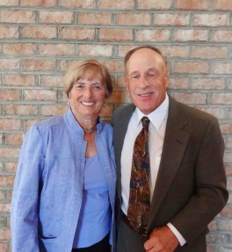
Jul: Susan sold her mother’s house in LA; Mark Aug: family vacation Tomales Bay; in May we joined Kirk of Kildaire in Cary
analyzing patient retention in clinical trials (Quintiles) Susan is active in the women’s group and Mark added his dulcimer “voice”
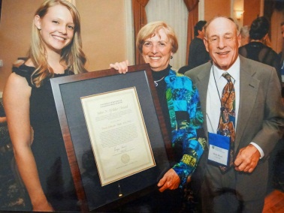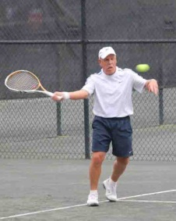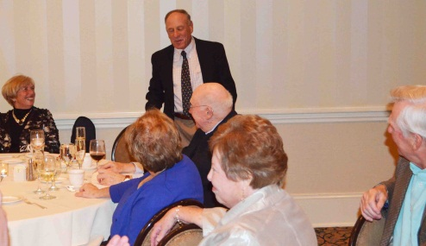
Oct: On behalf of her mother, Susan received the Oct/Nov: at the National Clay Court 70s in Pinehurst (dehydrated in singles,
U of Rochester’s John Wilder Award for a notable but won the consolation doubles); Susan threw a 70th birthday party for Mark
donation to the Eastman School of Music to endow (at table Bill & Ann Alexander – he is also a Sandoz Pharma alum, while Hal &
a harp student scholarship (with first recipient) Beverly Clew watch – he and Mark are both alums of Pitt’s GSPIA program

We leave in early Jan for Australia/New Zealand on a 6 week trip. Wishing you a healthy and memorable 2013! Mark & Susan

